**Exercise 1: Mocking and Stubbing**

**Implementation:**

**CODE:**

**pom.xml:**

<project xmlns="http://maven.apache.org/POM/4.0.0" xmlns:xsi="http://www.w3.org/2001/XMLSchema-instance" xsi:schemaLocation="http://maven.apache.org/POM/4.0.0 https://maven.apache.org/xsd/maven-4.0.0.xsd">

<modelVersion>4.0.0</modelVersion>

<groupId>myProject</groupId>

<artifactId>JunitExample</artifactId>

<version>0.0.1-SNAPSHOT</version>

<dependencies>

<!-- junit 5, unit test -->

<dependency>

<groupId>org.junit.jupiter</groupId>

<artifactId>junit-jupiter-engine</artifactId>

<version>5.10.2</version>

<scope>test</scope>

</dependency>

<dependency>

<groupId>org.mockito</groupId>

<artifactId>mockito-junit-jupiter</artifactId>

<version>5.11.0</version>

<scope>test</scope>

</dependency>

</dependencies>

</project>

**MyService.java:**

interface ExternalApi {

String getData();

}

class MyService {

private ExternalApi api;

public MyService(ExternalApi api) {

this.api = api;

}

public String fetchData() {

return api.getData();

}

}

**MyServiceTest.java:**

import static org.mockito.Mockito.*;

import static org.junit.jupiter.api.Assertions.*;

import org.junit.jupiter.api.Test;

import org.mockito.Mockito;

public class MyServiceTest {

@Test

public void testExternalApi() {

ExternalApi mockApi = Mockito.mock(ExternalApi.class);

when(mockApi.getData()).thenReturn("Mock Data");

MyService service = new MyService(mockApi);

String result = service.fetchData();

assertEquals("Mock Data", result);

}

}

**OUTPUT:**

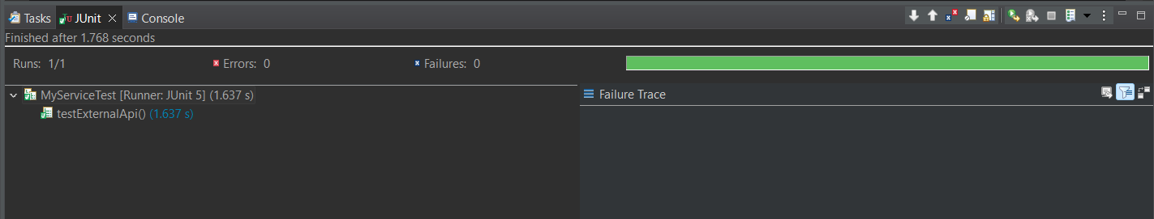

**Exercise 2: Verifying Interactions**

**Implementation:**

**CODE:**

**pom.xml:**

<project xmlns="http://maven.apache.org/POM/4.0.0" xmlns:xsi="http://www.w3.org/2001/XMLSchema-instance" xsi:schemaLocation="http://maven.apache.org/POM/4.0.0 https://maven.apache.org/xsd/maven-4.0.0.xsd">

<modelVersion>4.0.0</modelVersion>

<groupId>myProject</groupId>

<artifactId>JunitExample</artifactId>

<version>0.0.1-SNAPSHOT</version>

<dependencies>

<!-- junit 5, unit test -->

<dependency>

<groupId>org.junit.jupiter</groupId>

<artifactId>junit-jupiter-engine</artifactId>

<version>5.10.2</version>

<scope>test</scope>

</dependency>

<dependency>

<groupId>org.mockito</groupId>

<artifactId>mockito-junit-jupiter</artifactId>

<version>5.11.0</version>

<scope>test</scope>

</dependency>

</dependencies>

</project>

**MyService.java:**

interface ExternalApi {

String getData();

}

class MyService {

private ExternalApi api;

public MyService(ExternalApi api) {

this.api = api;

}

public String fetchData() {

return api.getData();

}

}

**MyServiceTest.java:**

import static org.mockito.Mockito.*;

import org.junit.jupiter.api.Test;

import org.mockito.Mockito;

public class MyServiceTest {

*@Test*

public void testVerifyInteraction() {

ExternalApi mockApi = Mockito.*mock*(ExternalApi.class);

*when*(mockApi.getData()).thenReturn("Mock Response");

MyService service = new MyService(mockApi);

service.fetchData();

*verify*(mockApi).getData();

*verify*(mockApi, *times*(1)).getData();

*verifyNoMoreInteractions*(mockApi);

}

}

**OUTPUT:**

